**ASSIGNMENT – V**

1. **Create table emp with attributes emp_id, emp_name, hire_date, job_id, salary and commission. Use suitable datatype for each attribute.**

**Ans.** create table emp

(

emp_id number(4) primary key,

emp_name varchar2(25),

hire_date date,

job_id number(2),

salary number(6,2),

commission number(2,2)

);

1. **a. Show the structure of the emp table. Select all data from the emp table.**

**Ans.**

1. desc emp;

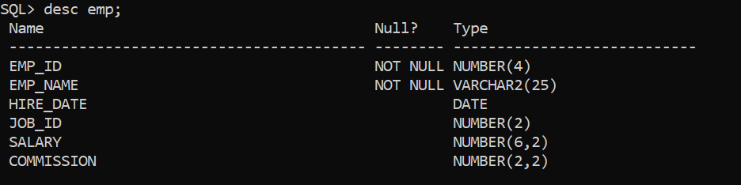

1. insert into emp values(123,'Rahul','10-02-1991',1,2300,0.23);

insert into emp values(124,'Gandhi','11-02-1993',3,3300,0.23);

insert into emp values(125,'Sheela','11-11-2005',3,2500,0.23);

select * from emp;

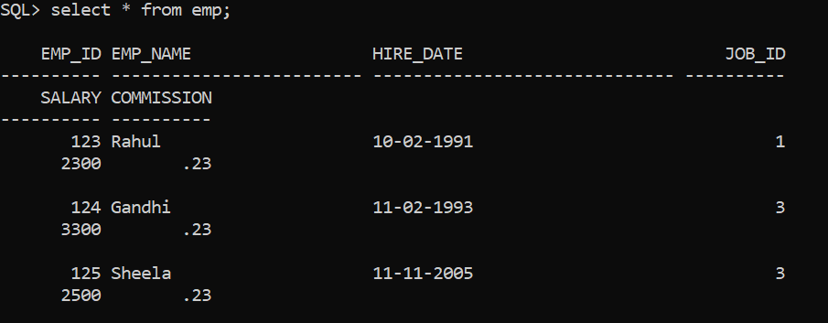

**b. Create a query to display the name, job_id, hire_date, and**

**employee_id for each employee, with employee_id appearing first.**

**Provide an alias STARTDATE for the hire date column.**

**Ans.** select emp_id, job_id, hire_date as STARTDATE from emp;

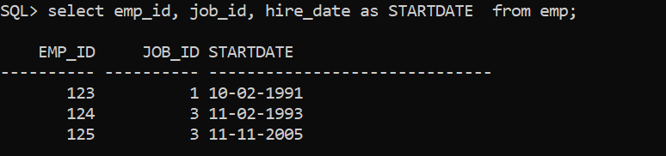

**c. Create a query to display the unique job_id from the employee table.**

**Ans.** select distinct job_id from emp;

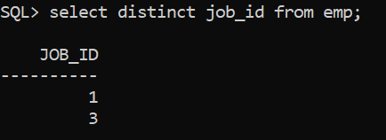

**d. Display the last name concatenated with job id, separated by a**

**comma and space and name the column Employee and Title.**

**Ans.** select emp_id||', '||emp_name as "Employee and Title" from emp;

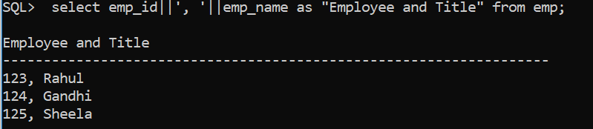

**e. Write a query to find out the annual salary of each employee.**

**Ans.** select emp_id , salary*12 as ANNUALSALARY from emp;

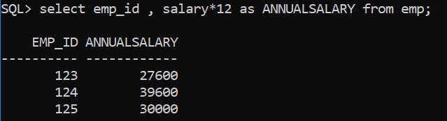

**►Retrieving Data:writing basic SQL SELECT statements**

**[Set operations (AND, OR, NOT)]**

1. **Find the emp_id, emp_name, hire_date, job_id and salary for all employees whose job_id is 1 and salary more than 10,000.**

**Ans.** select emp_id, emp_name, hire_date, job_id, salary from emp

where job_id = 1 and salary >10000;

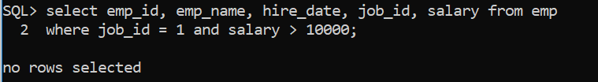

1. **Find the emp_id, emp_name, hire_date, job_id and salary for all employees whose job_id is not 2.**

**Ans.** select emp_id, emp_name, hire_date, job_id, salary from emp

where job_id != 2;

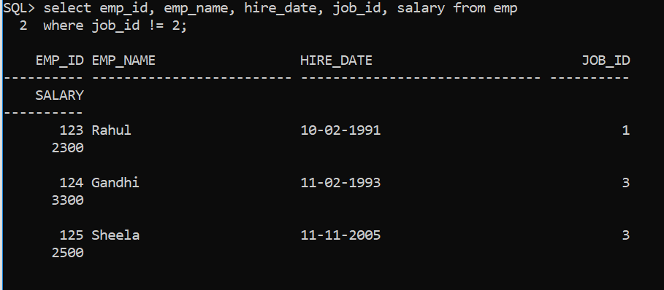

**[LIKE Operator, SQL Wildcards]**

1. **Find all employee with an emp_name starting with "a".**

**Ans.**  select * from emp

where emp_name like ‘a%’;

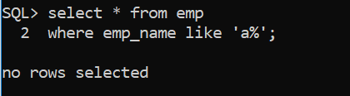

1. **Find all employee with an emp_name ending with "a".**

**Ans.** select * from emp

where emp_name like ‘%a’;

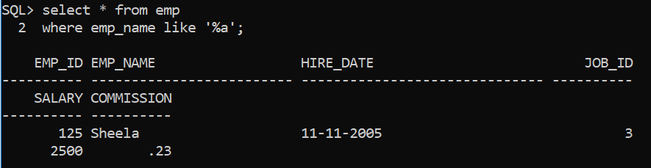

1. **Find all employee with an emp_name that have "r" in the second position.**

**Ans.** select * from emp

where emp_name like ‘_r%’;

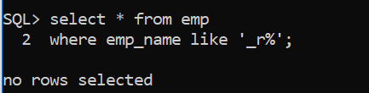

1. **Find all employee with an emp_name that starts with "a" and are at least 3 characters in length.**

**Ans.** select * from emp

where emp_name like ‘a__%’;

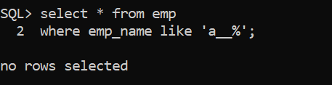

1. **Find all employee with an emp_name that starts with "a" and ends with "o".**

**Ans.** select * from emp

where emp_name like ‘a%o’;

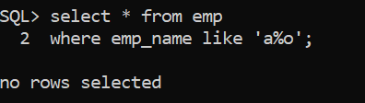

1. **Find all employee with an emp_name that does NOT start with "a".**

**Ans.** select * from emp

where emp_name not like ‘a%’;

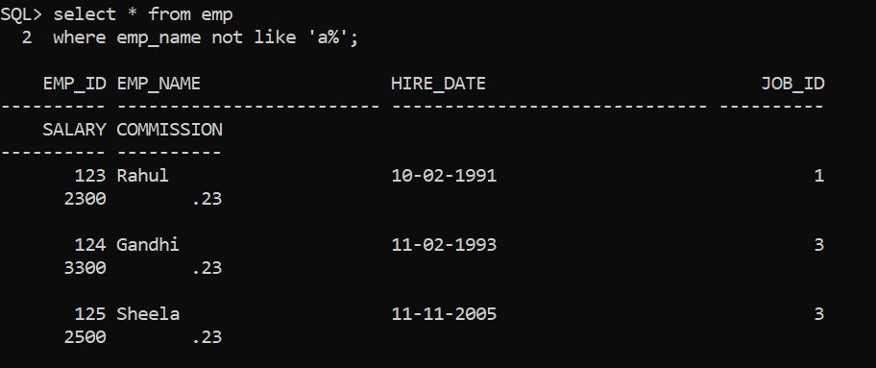

1. **Display the names of employees who have an 'a' and an 'e' in their names.**

**Ans.** select * from emp

where emp_name like ‘%a%’ and emp_name like ‘%e%’;

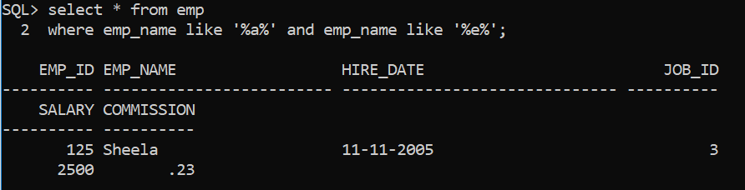

1. **Display the name, total monthly salary of each employees i.e. salary along with commission of all those employees whose name starts with ‘A’.**

**Ans.** select emp_name, salary + salary*commission

as totalmonthlysalary from emp

where emp_name like ‘A%’;

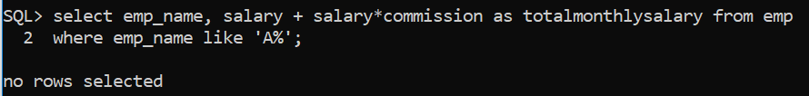

1. **Find all employees with an emp_name that starts with "ra".**

**Ans.** select * from emp

where emp_name like ‘ra%’;



1. **Write a query that displays all employees whose names starts with J, A or M.**

**Ans.** select * from emp

where emp_name like ‘A%’ or emp_name like ‘J%’ or emp_name like ‘M%’;

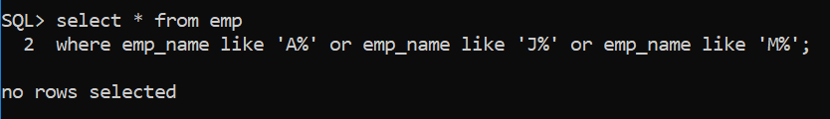

**[IN Operator, Between Operator]**

1. **Display the name and job_id of all employees whose job ids are 1, 2, and 3.**

**Ans.** select emp_name from emp

where job_id in (1,2,3);

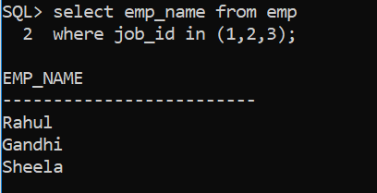

1. **Display the name and job_id of all employees whose job ids are not in 1, 2.**

**Ans.** select emp_name from emp

where job_id not in (1,2);

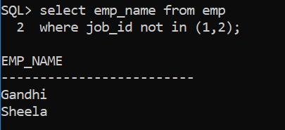

1. **Display the name and salary of employees who earn between 10000 and 12000.**

**Ans.** select emp_name, salary from emp

where salary between 10000 and 12000;

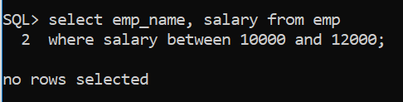

1. **Display the name and salary of employees who earn not between 5000 and 12000, and job_id in 1 and 2.**

**Ans.** select emp_name, salary from emp

where salary not between 5000 and 12000 and job_id in (1,2);

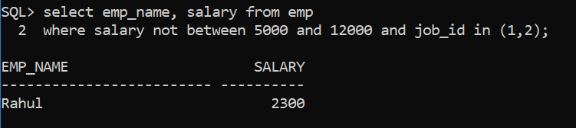

**[Aggregate functions MIN (), MAX (), COUNT (), AVG () and SUM ()]**

1. **Find the total "salary" of all employees from "emp" table.**

**Ans.** select sum(salary) from emp;

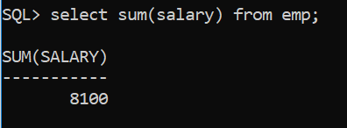

1. **Find the average "salary" of all employees from "emp" table where job_id is 1.**

**Ans.** select avg(salary) from emp

where job_id = 1;

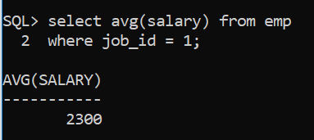

1. **Find the minimum “commission" given to employees whose job_id is not 1.**

**Ans.** select min(commission) from emp

where job_id != 1;

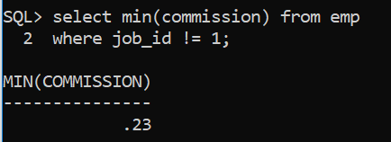

1. **Find the maximum “salary" given to employees whose job_id is 1.**

**Ans.** select max(salary) from emp

where job_id = 1;

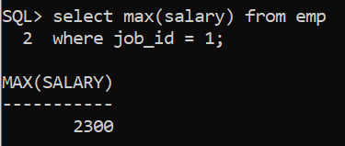

1. **Find the total number of employees belong to job_id=2.**

**Ans.** select count(*) from emp

where job_id = 2;

